**JENKINS**

*Jenkins is an open source continuous integration/continuous delivery and deployment (CI/CD) automation software DevOps tool written in the Java programming language. It is used to implement CI/CD workflows called pipelines.*

## **Prerequisites:**

Minimum hardware requirements:

* 256 MB of RAM
* 1 GB of drive space (although 10 GB is a recommended minimum if running Jenkins as a Docker container)

Recommended hardware configuration for a small team:

* 4 GB+ of RAM
* 50 GB+ of drive space

Software requirements:

* Java. Check for the java –version in the command prompt.

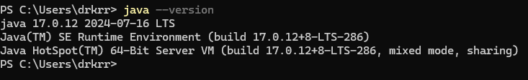

***TASK*: *How to install Jenkins on Windows***

**Step 1**: On opening the Windows Installer, an **Installation Setup Wizard** appears

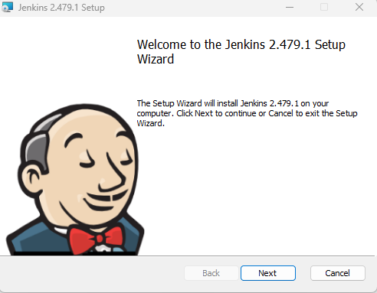

**Step 2:** Select the destination folder to store your Jenkins Installation.

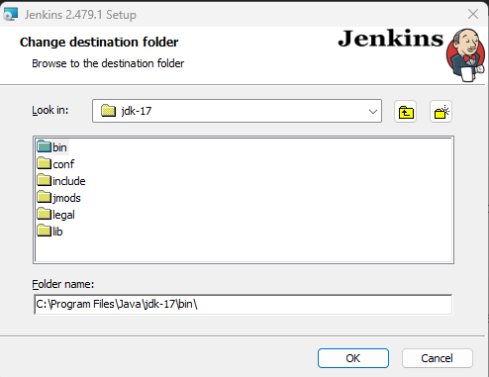

**Step 3:** **Local System(Windows equivalent of root)** which will grant Jenkins full access to your machine and services.

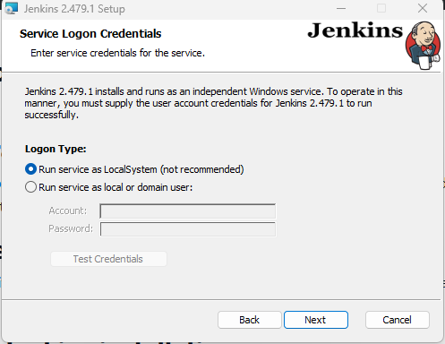

Step 4: Specify the port on which Jenkins will be running.

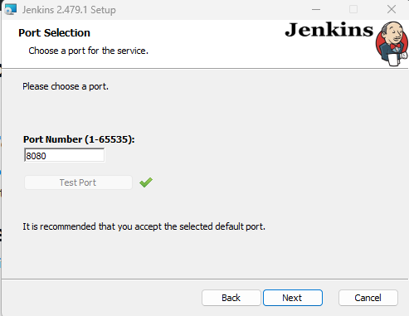

**Step 5:** The installation process checks for Java on your machine and prefills the dialog with the Java home directory. If the needed Java version is not installed on your machine, you will be prompted to install it.

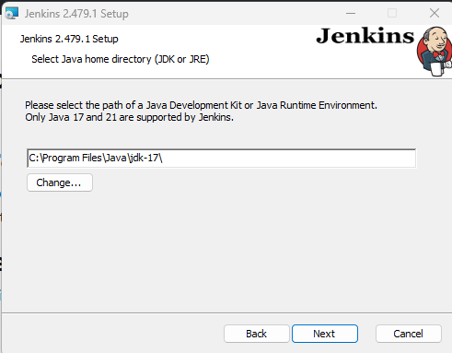

**Step 6:** Select start services to install Jenkins .

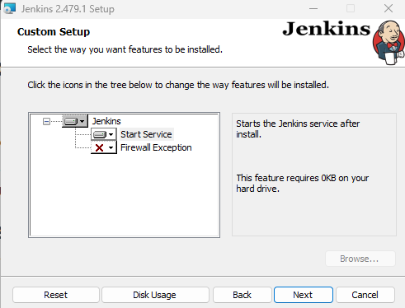

**Step 7:** Click on the Install button to start the installation of Jenkins.

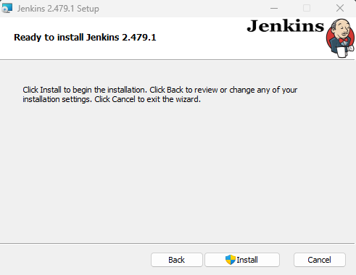

**Step 8:** Finish Jenkins installation.

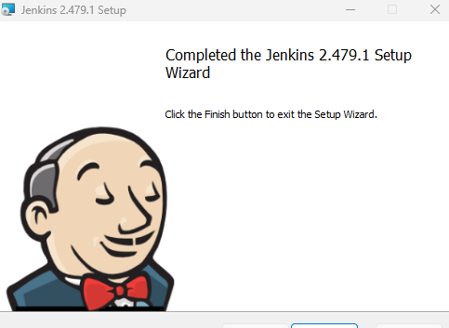

**Step 9:** Browse to <http://localhost:8080>.For default installation location to C:\Program Files\Jenkins, a file called **initialAdminPassword**can be found under C:\Program Files\Jenkins\secrets.

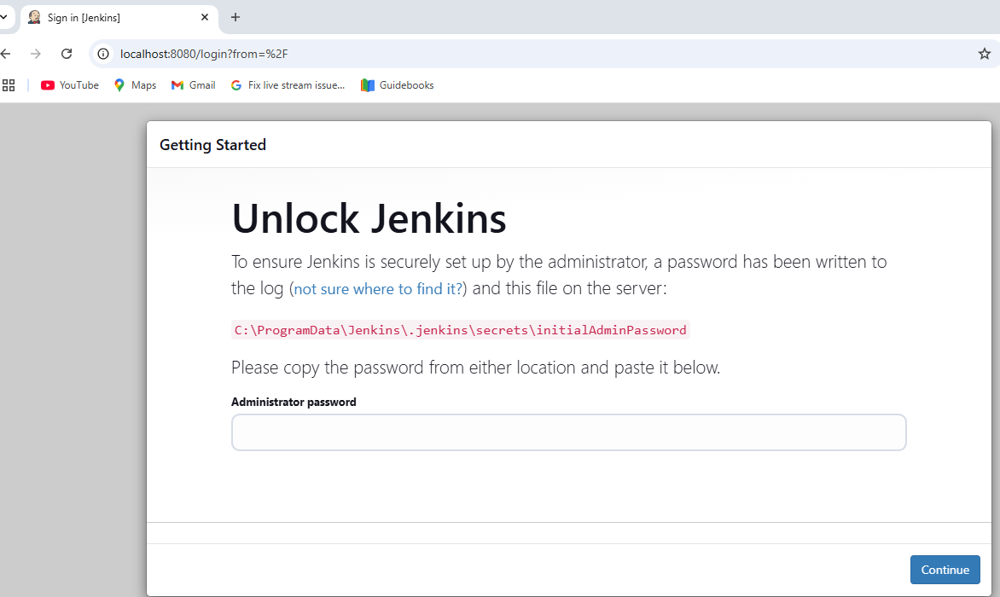

### Step 10: Customizing Jenkins with plugins.

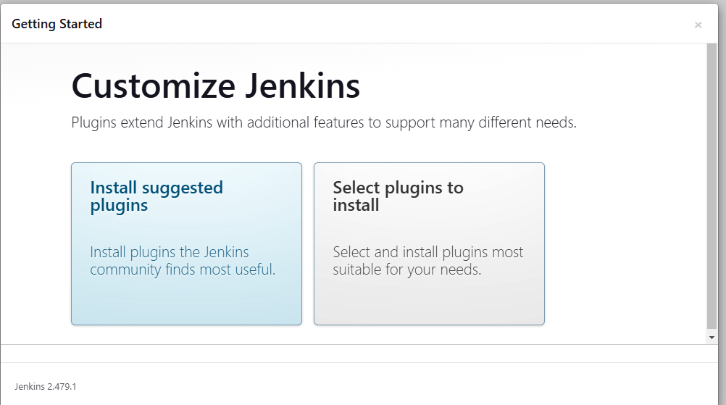

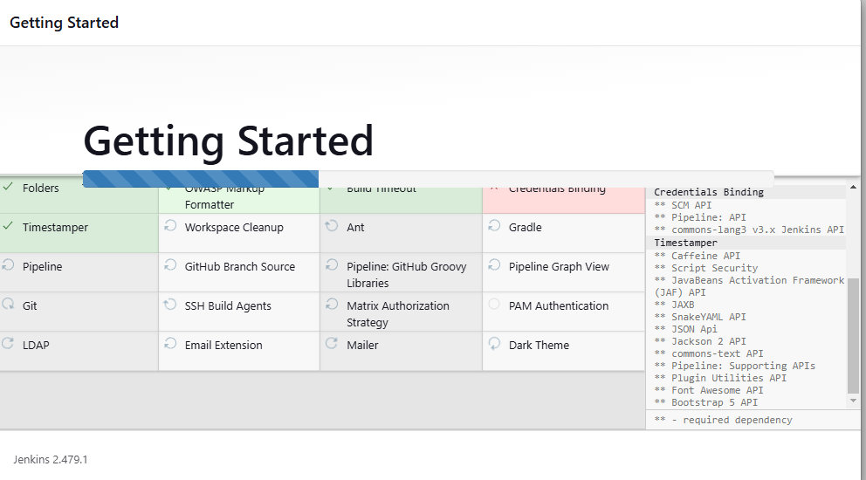

**Step 11:** create your first administrator user.

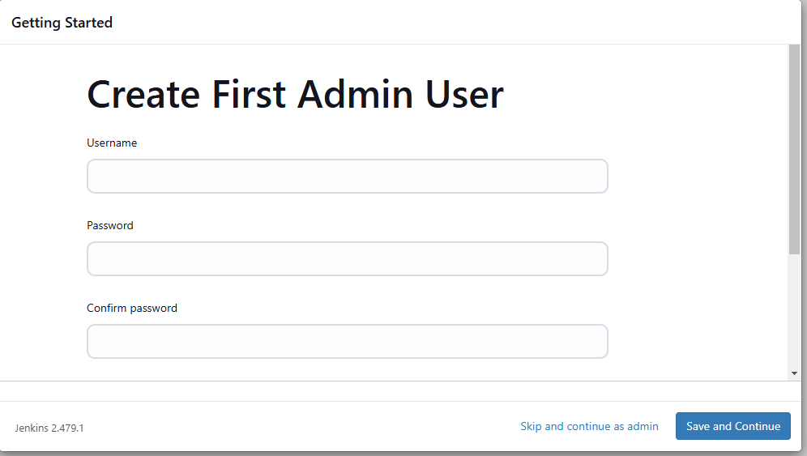

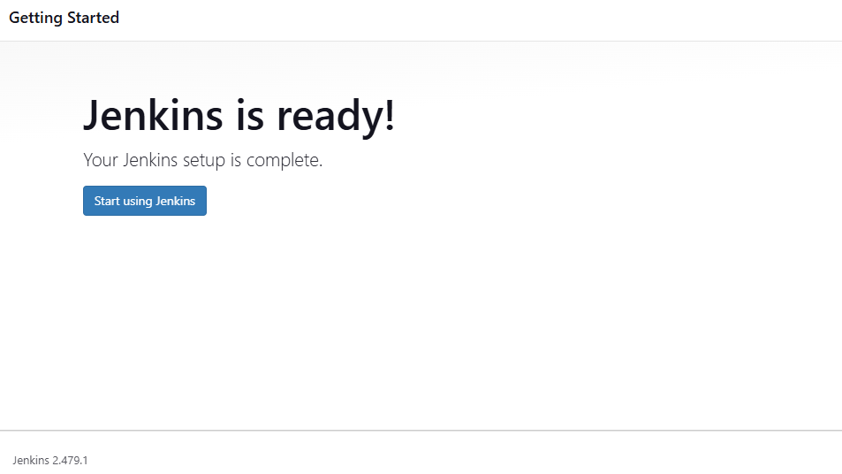

**Step 12:** Successfully logged in Jenkins.

